By: Heba Hassan 6521 Nourhan Waleed 6609 Fatema Mohamed 6655

Numerical Analysis Project 1 Report

**Pseudocodes:**

1. **Bisection Method:**

1. Start

2. Define function f(x)

3. Input

a. Lower and Upper guesses x0 and x1

b. tolerable error e

4. If f(x0)*f(x1) > 0

print "Incorrect initial guesses"

goto 3

End If

5. Do

x2 = (x0+x1)/2

If f(x0)*f(x2) < 0

x1 = x2

Else

x0 = x2

End If

while abs(f(x2) > e

6. Print root as x2

7. Stop

1. **False Position(Regula Falsi):**
2. 1. Start
3. 2. Define function f(x)
4. 3. Input
5. a. Lower and Upper guesses x0 and x1
6. b. tolerable error e
8. 4. If f(x0)*f(x1) > 0
9. print "Incorrect initial guesses"
10. goto 3
11. End If
12. 5. Do
13. x2 = (x0+x1)/2
15. If f(x0)*f(x2) < 0
16. x1 = x2
17. Else
18. x0 = x2
19. End If
21. while abs(f(x2) > e
23. 6. Print root as x2
24. 7. Stop

**3.Fixed Point:**

1. Start

2. Define function as f(x)

3. Define convergent form g(x)

4. Input:

a. Initial guess x0

b. Tolerable Error e

c. Maximum Iteration N

5. Initialize iteration counter: step = 1

6. Do

x1 = g(x0)

step = step + 1

If step > N

Print "Not Convergent"

Stop

End If

x0 = x1

While abs f(x1) > e

7. Print root as x1

8. Stop

Note: g(x) is obtained by rewriting f(x) in the form of x = g(x)

**4.Newton Raphson:**

1. Start

2. Define function as f(x)

3. Define derivative of function as g(x)

4. Input:

a. Initial guess x0

b. Tolerable Error e

c. Maximum Iteration N

5. Initialize iteration counter step = 1

6. Do

If g(x0) = 0

Print "Mathematical Error"

Stop

End If

x1 = x0 - f(x0) / g(x0)

x0 = x1

step = step + 1

If step > N

Print "Not Convergent"

Stop

End If

While abs f(x1) > e

7. Print root as x1

8. Stop

**5.Secant Method:**

1. Start

2. Define function as f(x)

3. Input:

a. Initial guess x0, x1

b. Tolerable Error e

c. Maximum Iteration N

4. Initialize iteration counter step = 1

5. Do

If f(x0) = f(x1)

Print "Mathematical Error"

Stop

End If

x2 = x1 - (x1 - x0) * f(x1) / ( f(x1) - f(x0) )

x0 = x1

x1 = x2

step = step + 1

If step > N

Print "Not Convergent"

Stop

End If

While abs f(x2) > e

6. Print root as x2

7. Stop

**Data Structures:**

*Dictionaries*

Dictionaries were essential in our efforts to store the user’s input and method’s output in JSON files, for easy access across all functions. JSON files are easily convertible to dictionaries.

*DataFrames*

Pandas DataFrames were useful in outputting the iterations in a neat tabular form, as well as in plotting the simulation.

**Analysis and Sample Runs:**

*Test 1*

Expression: x^2-3

* Bisection method (with last frame of simulation) 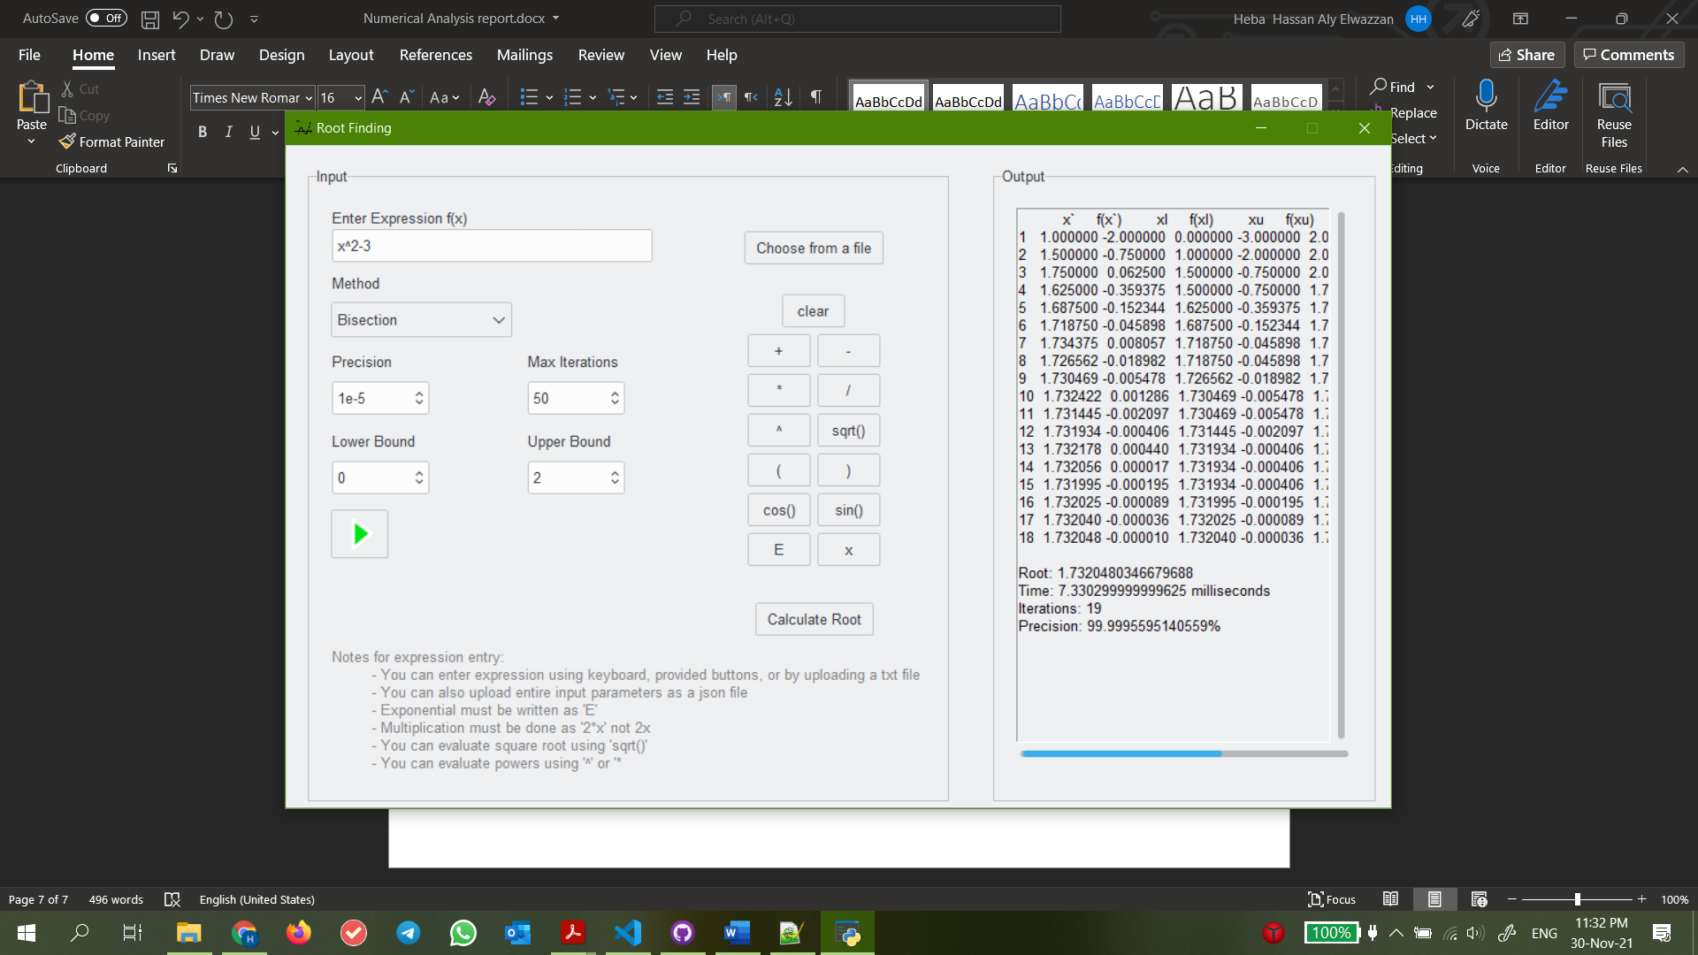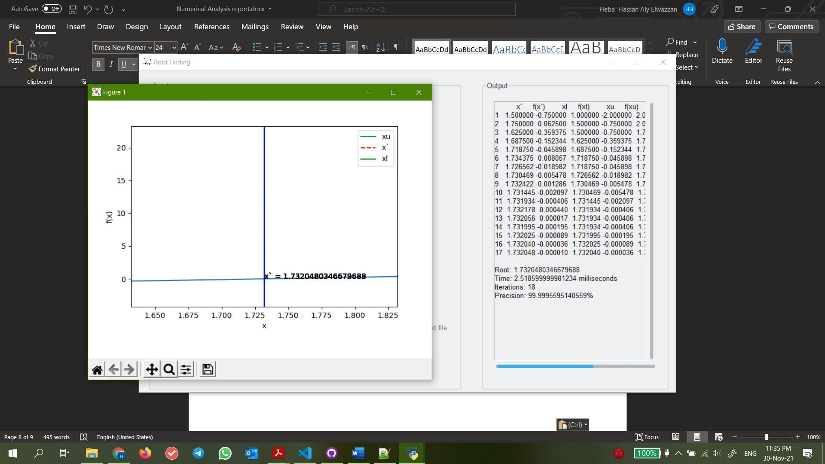
* Regula Falsi Method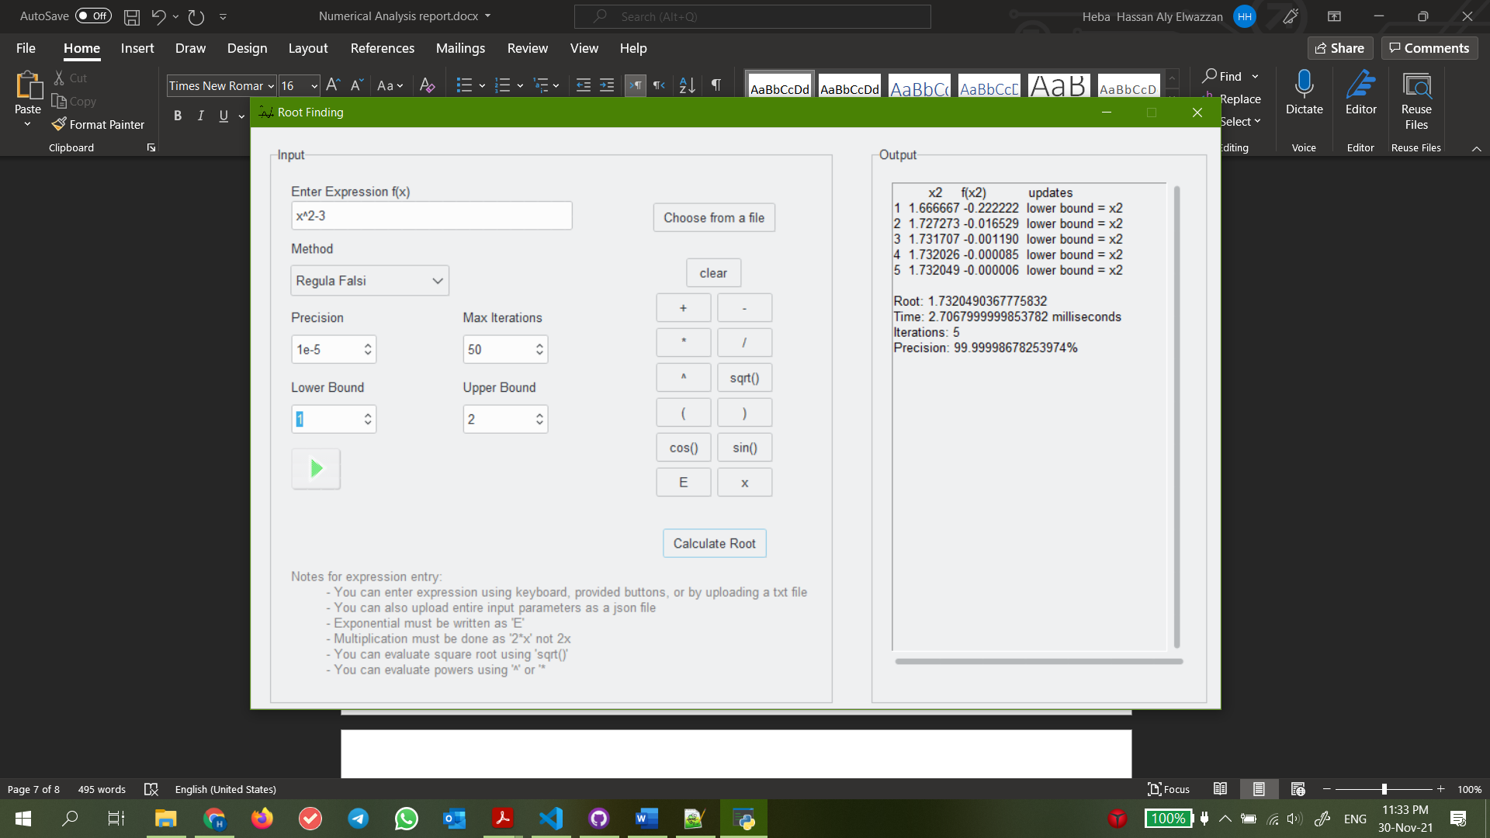
* Fixed Point Method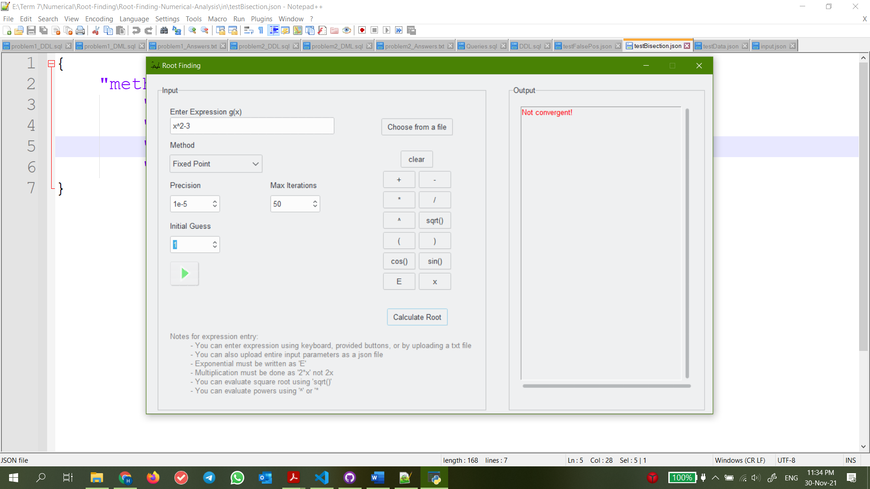
* Newton Raphson Method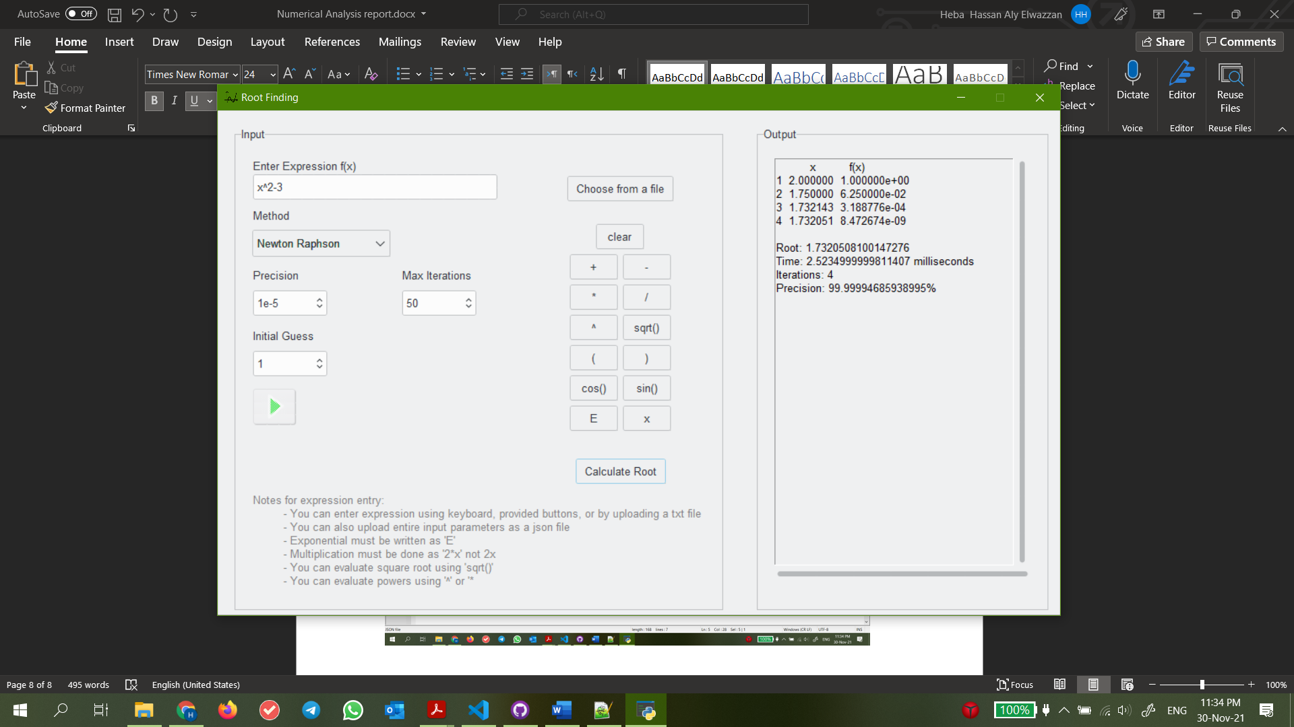
* Secant Method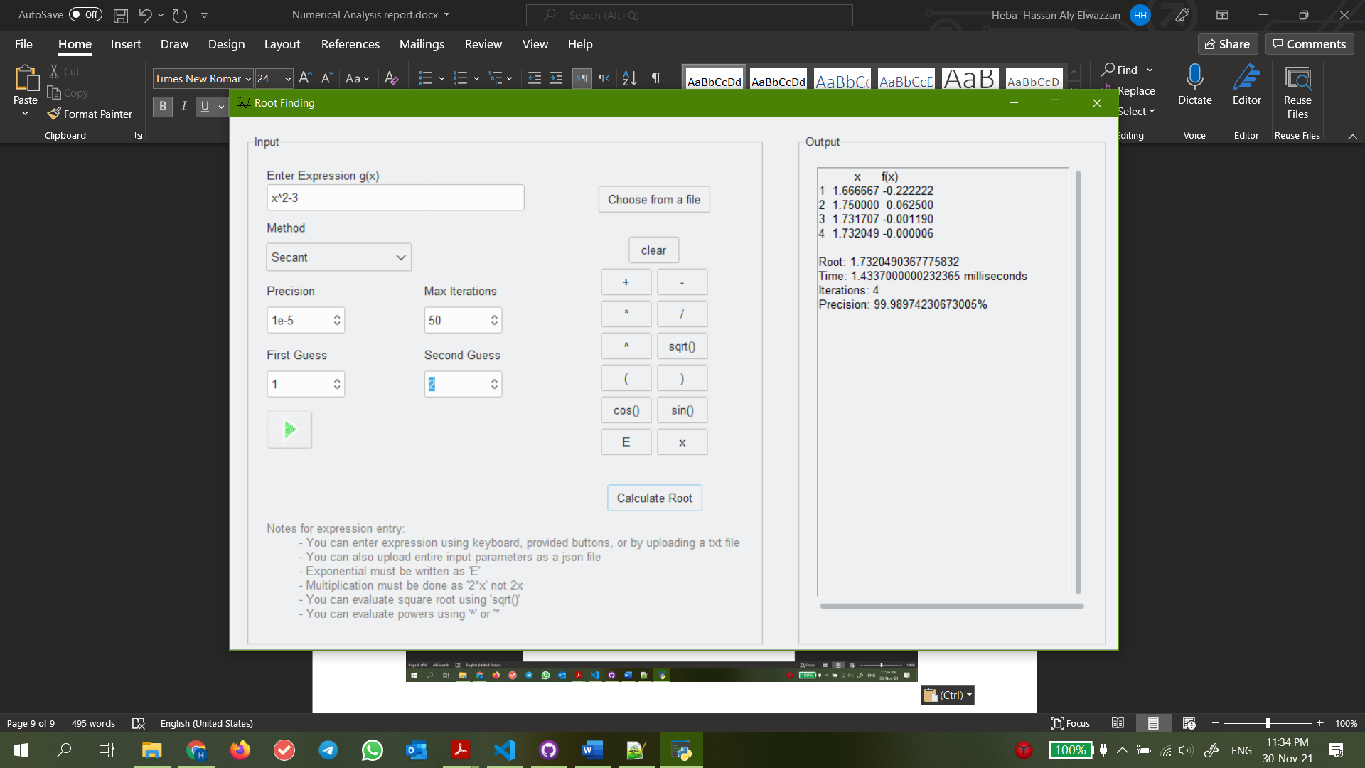

Observations:

Bisection method took the most iterations to reach an acceptable root as well as the longest time.

Secant method took the least time.

Fixed point method was not able to converge on a root.

*Test 2*

Expression: E^-x*(3.2*sin(x)-0.5*cos(x))

* Bisection method 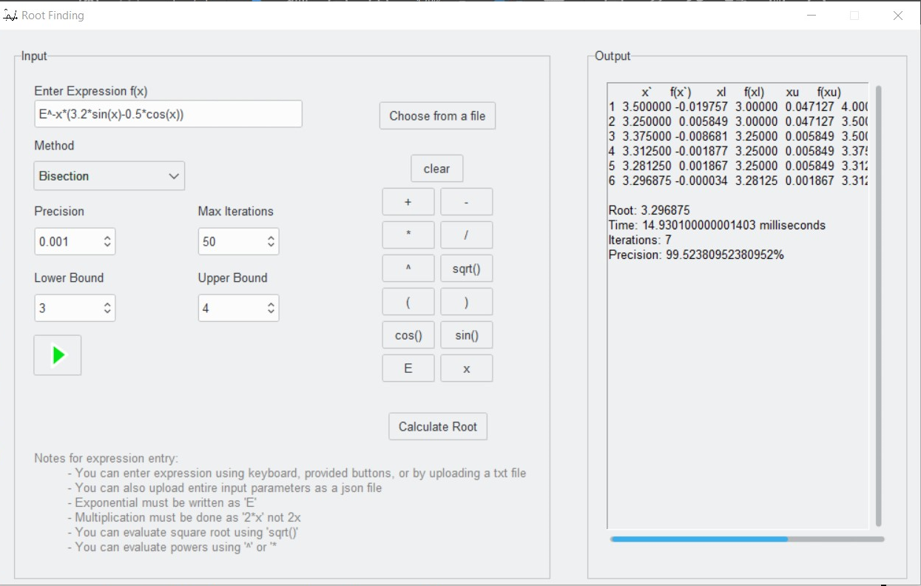 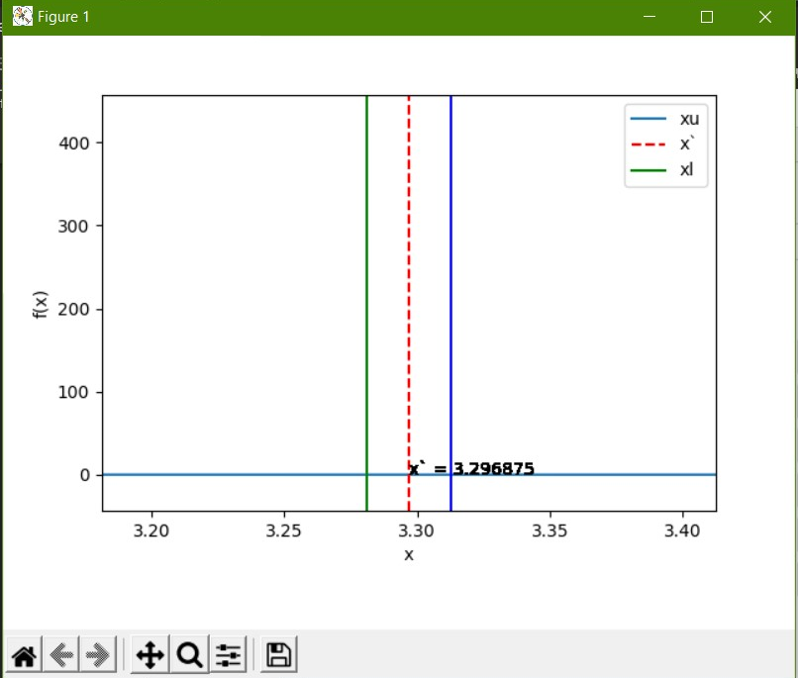
* Regula Falsi method 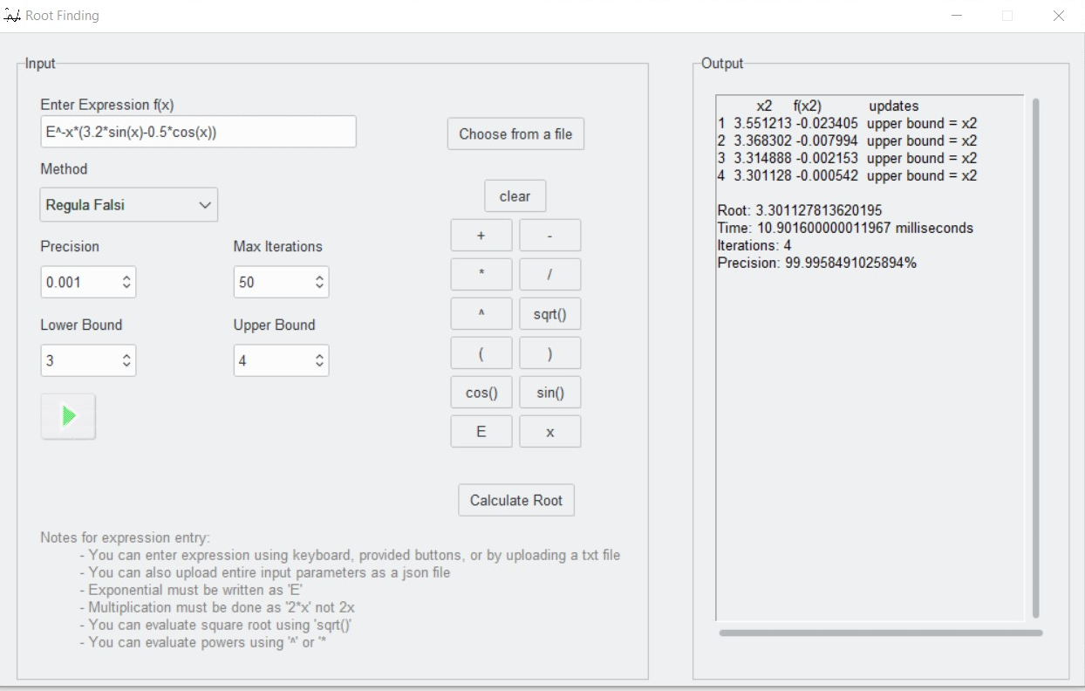
* Fixed Point method 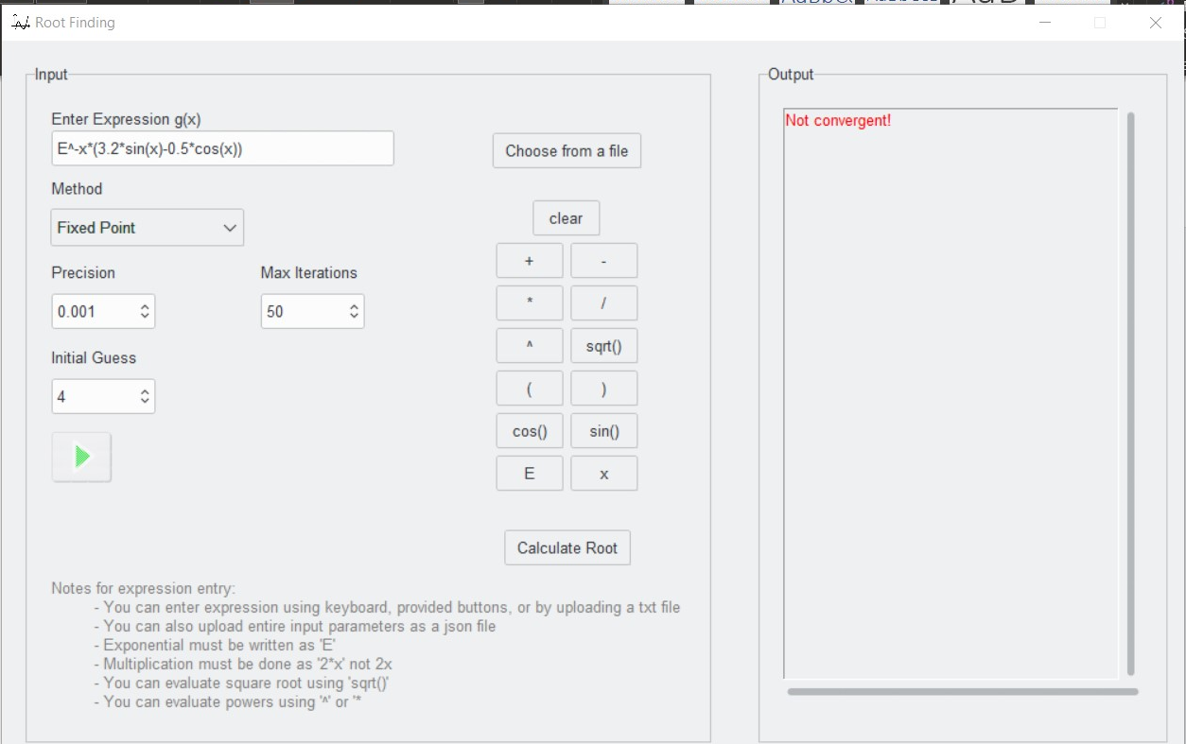
* Newton Raphson method 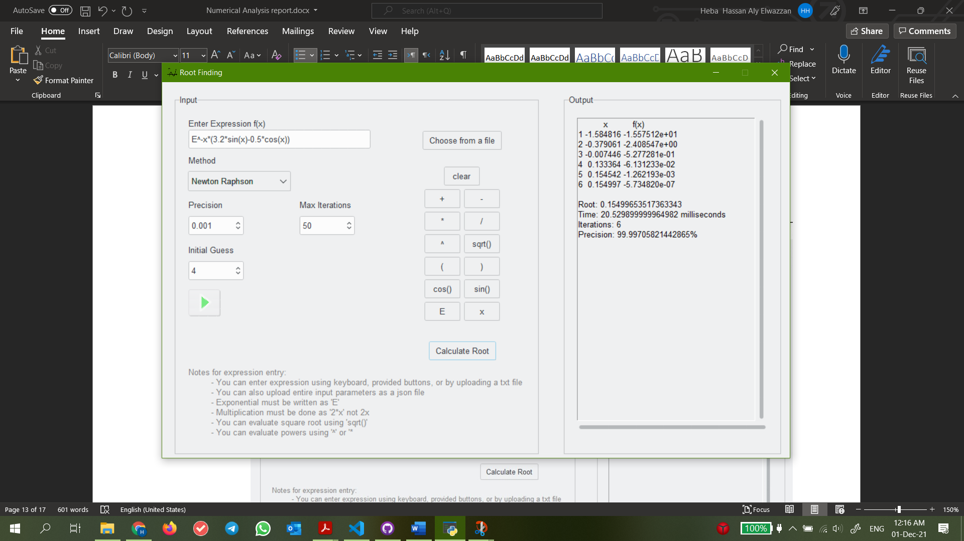
* Secant method 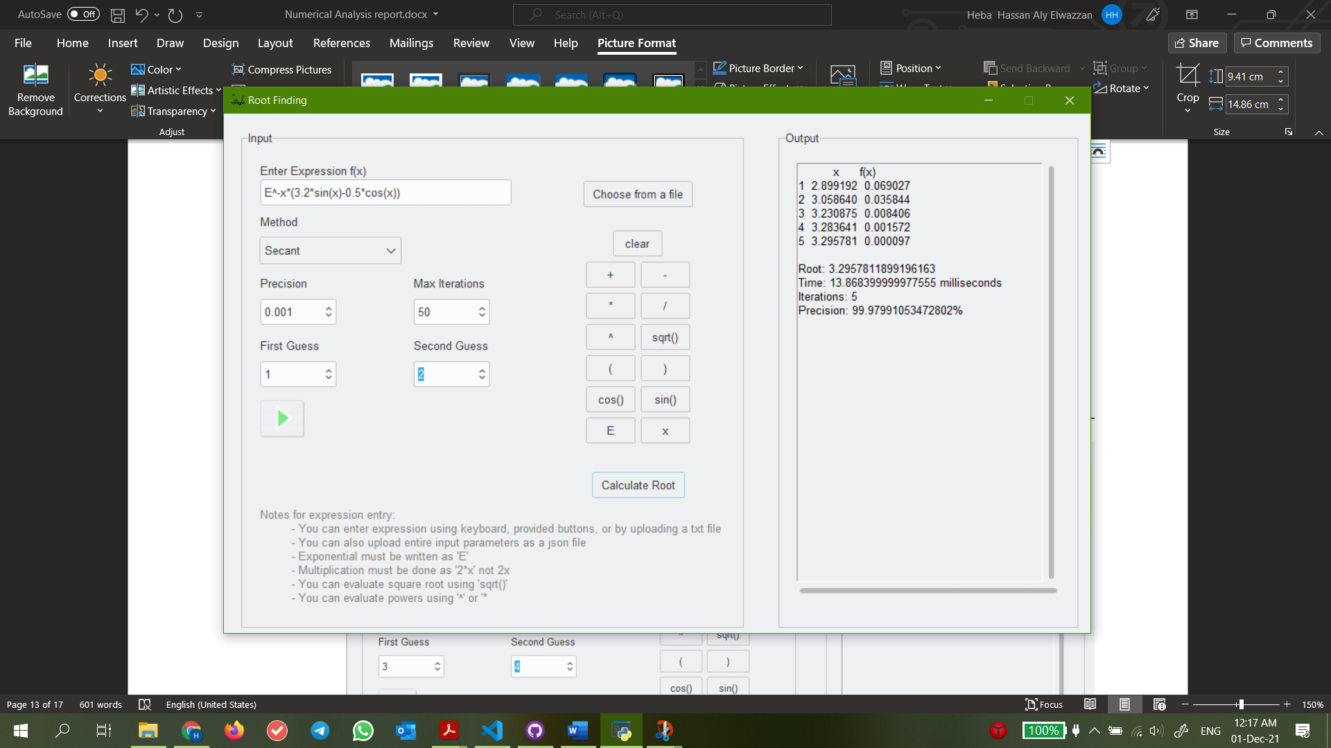

Observations

Despite the low precision, function performance was generally poor in regard to time taken. The function was simply too complicated.

Fixed point was unable to converge. This is because we treated the f(x) as g(x) like in test 1. In the next tests we will transform f(x) into a suitable g(x) and pass them to Fixed Point.

*Test 3*

Expression: x^2-2*x-3

* Bisection method 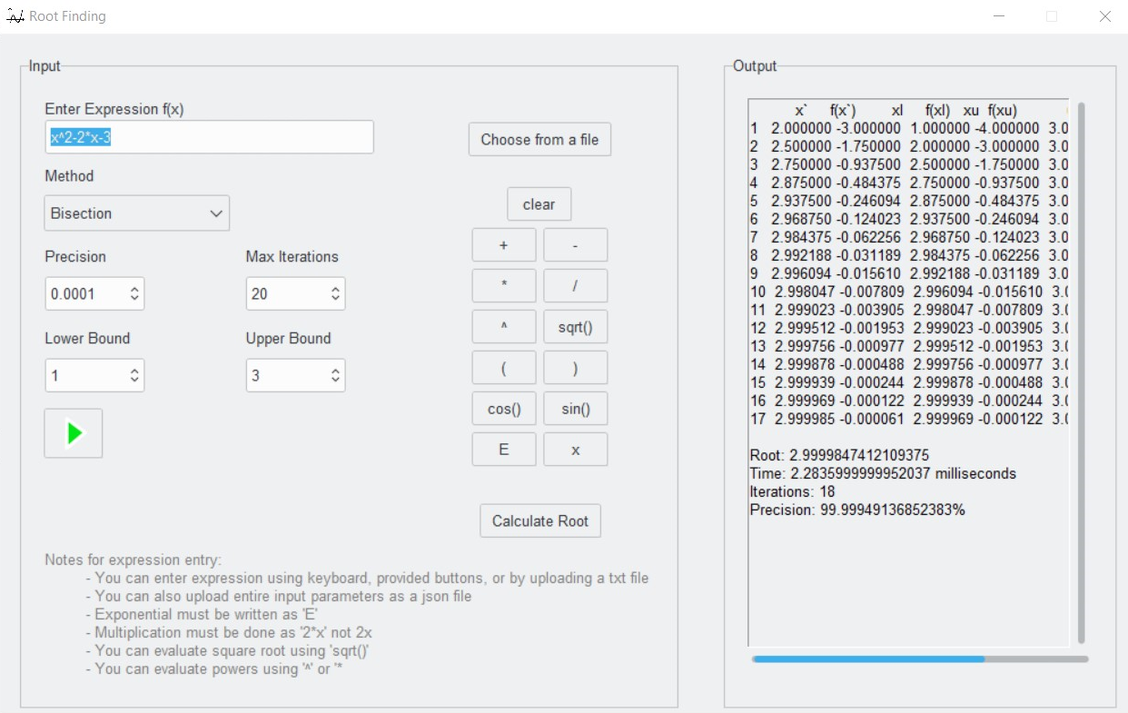 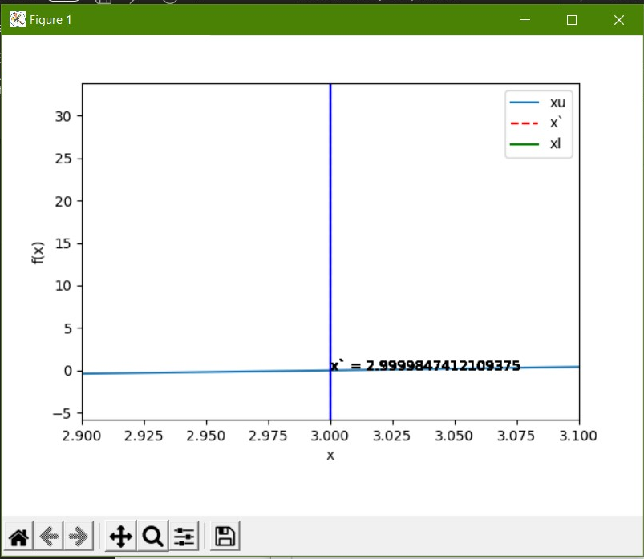
* Regula Falsi method 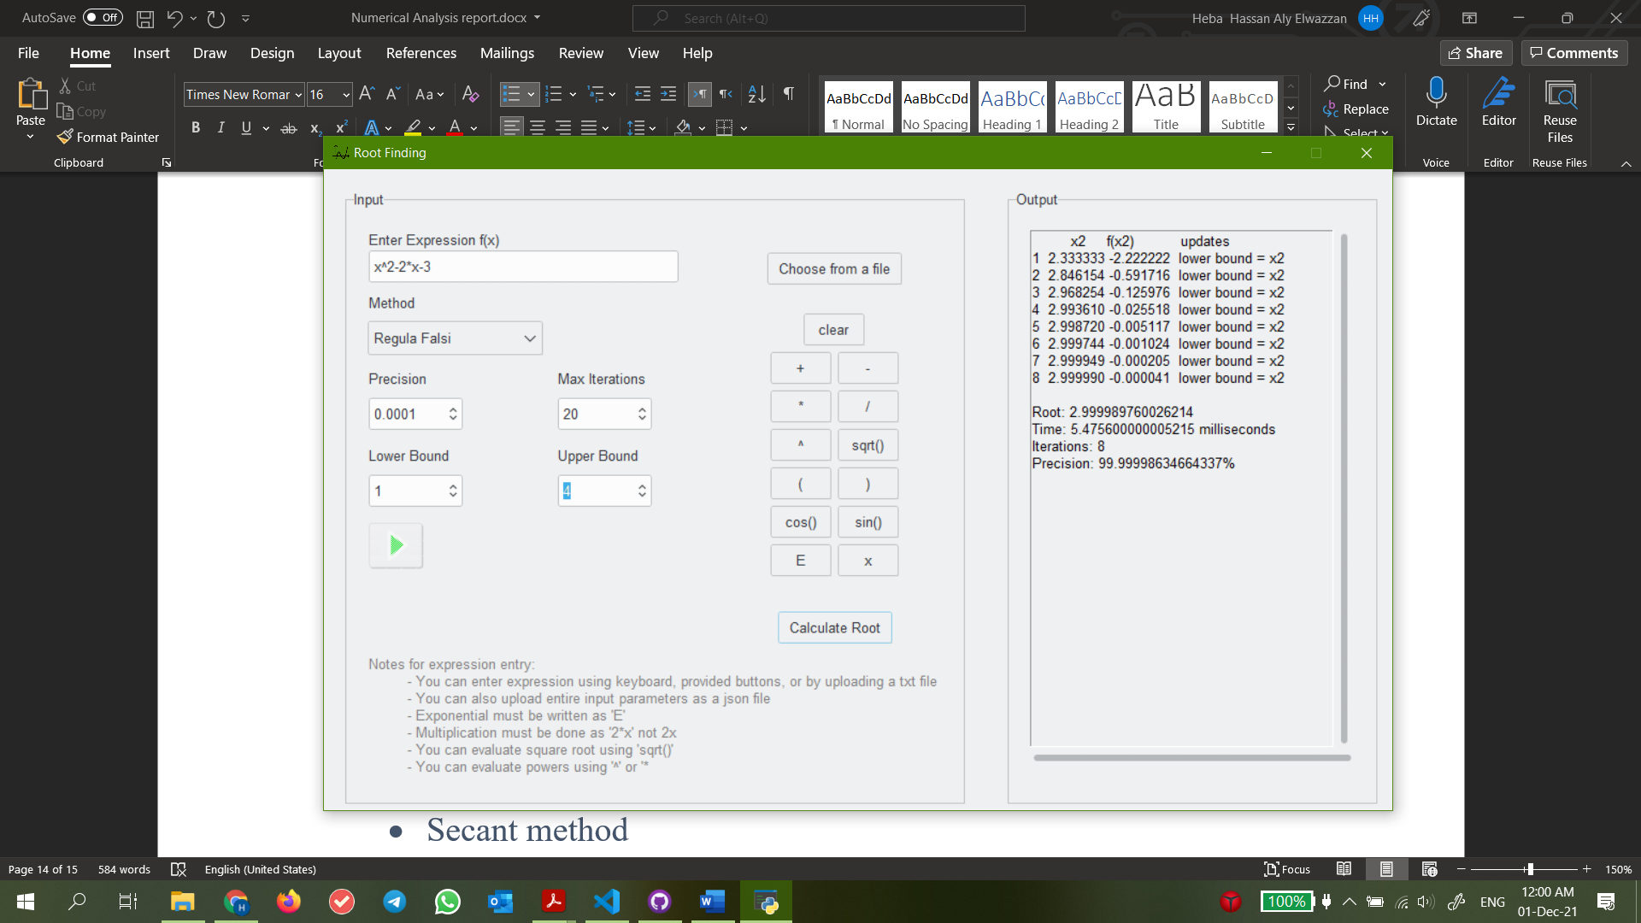
* Fixed Point method 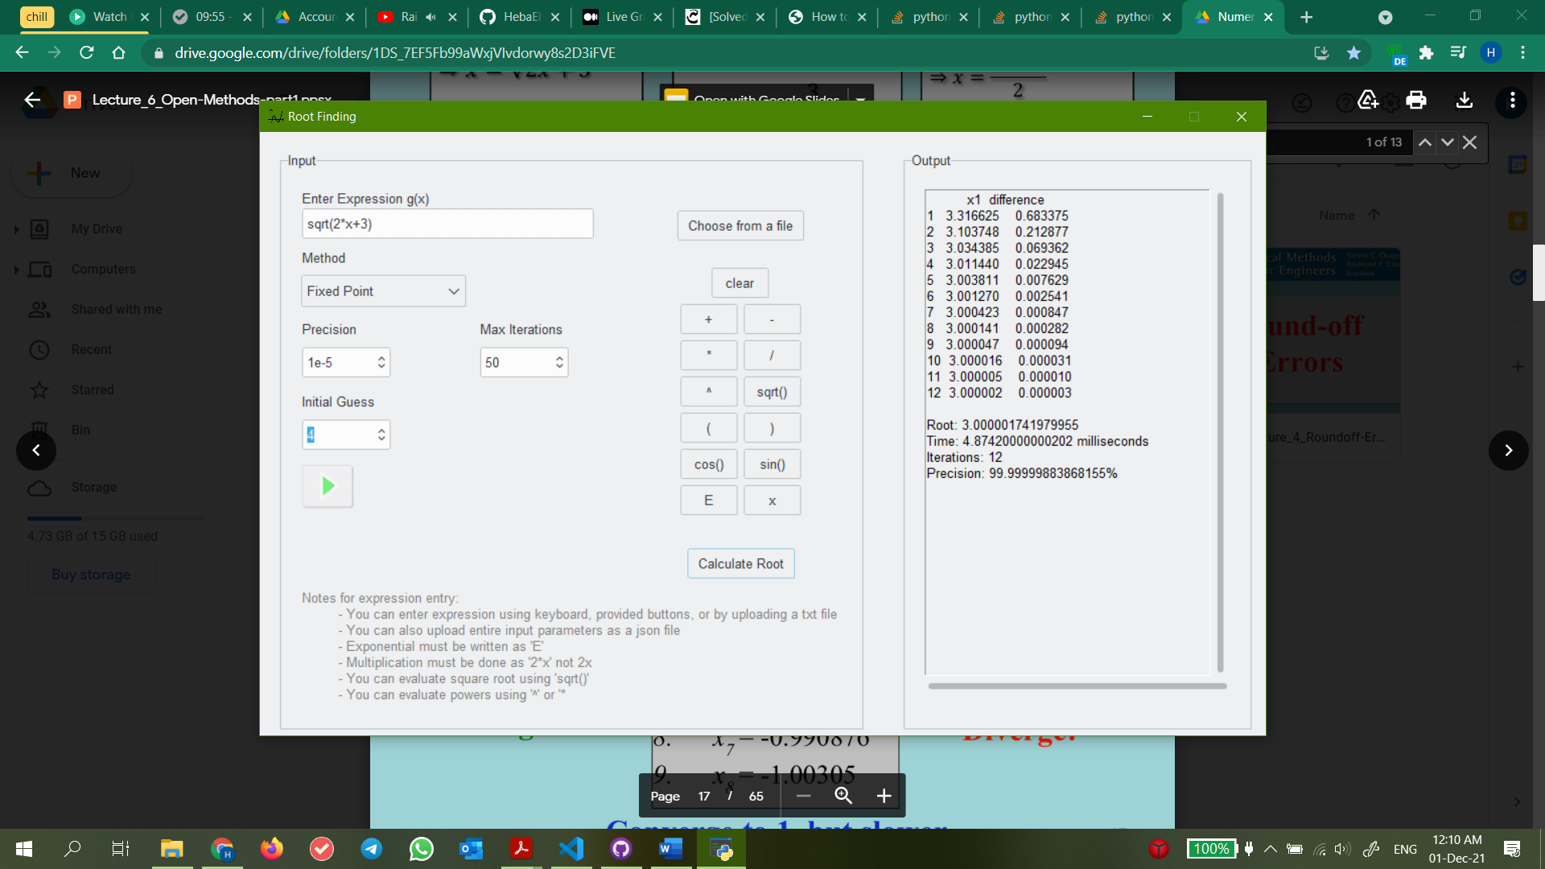
* Newton Raphson method 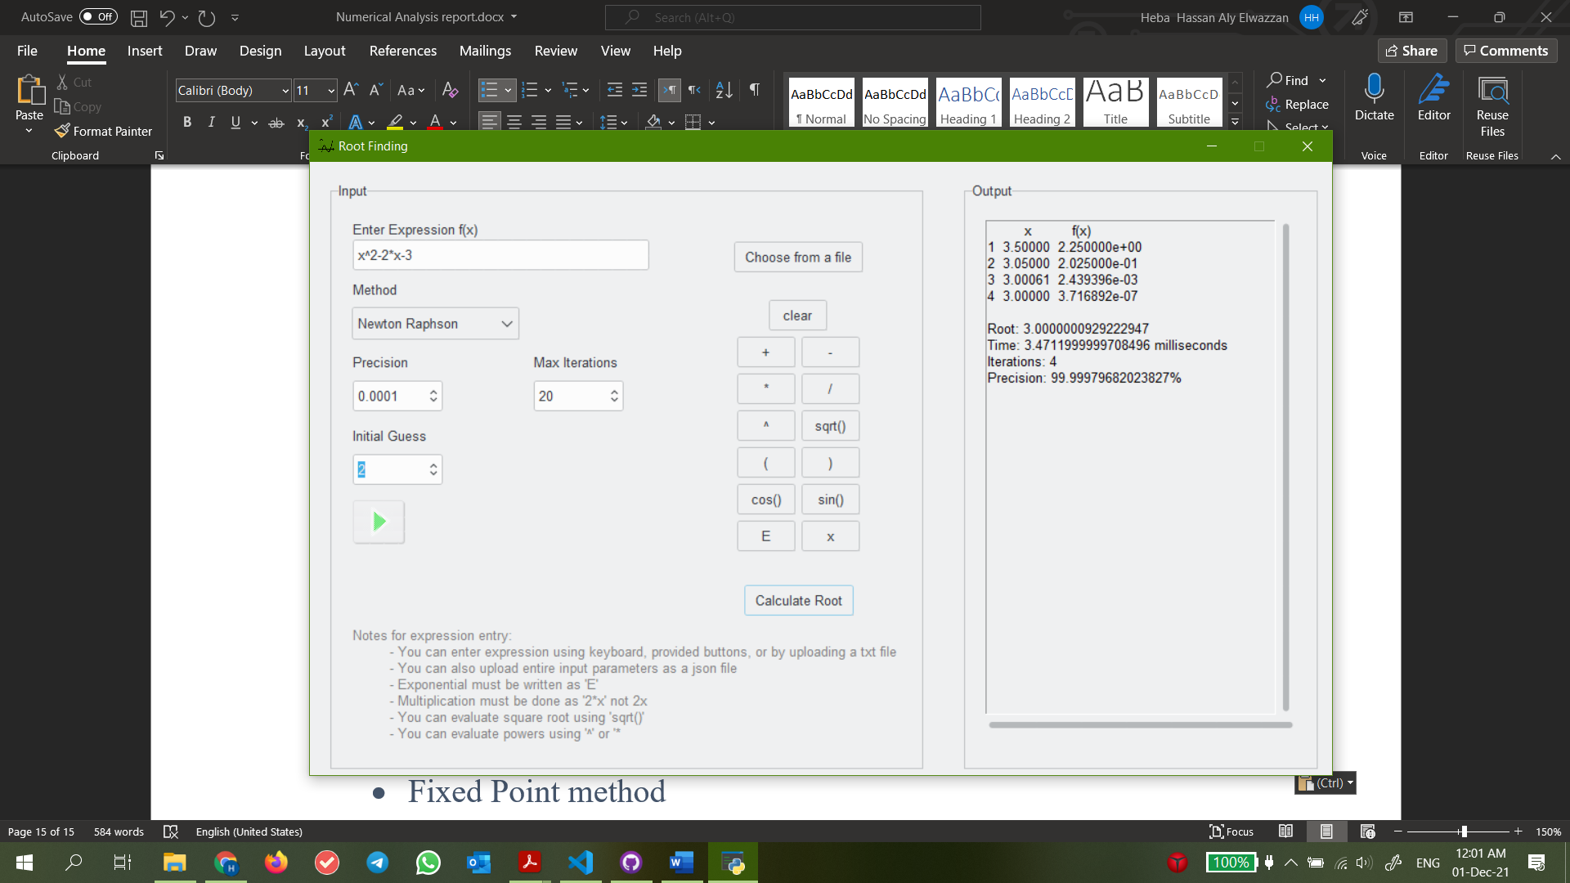
* Secant method 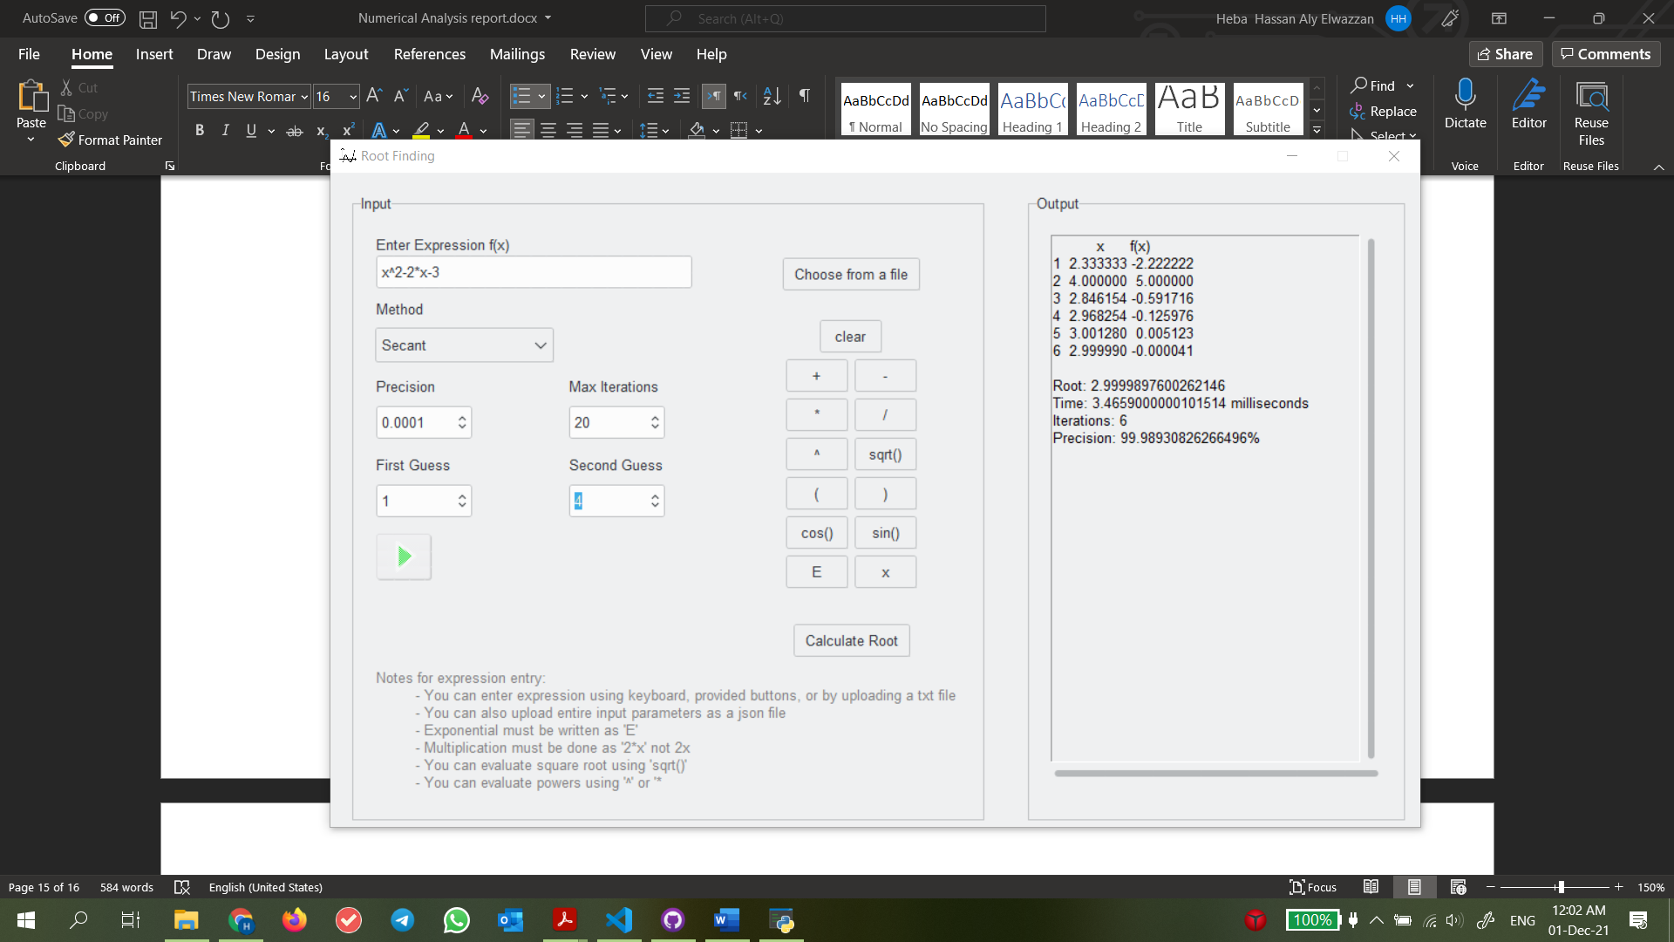

Observations

Fixed point was able to converge as we had provided a suitable g(x) this time.

The most efficient (from number of iterations perspective) was Newton Raphson while the least was Bisection again.

*Test 4*

Expression: x^2-2*x-3

* Bisection method 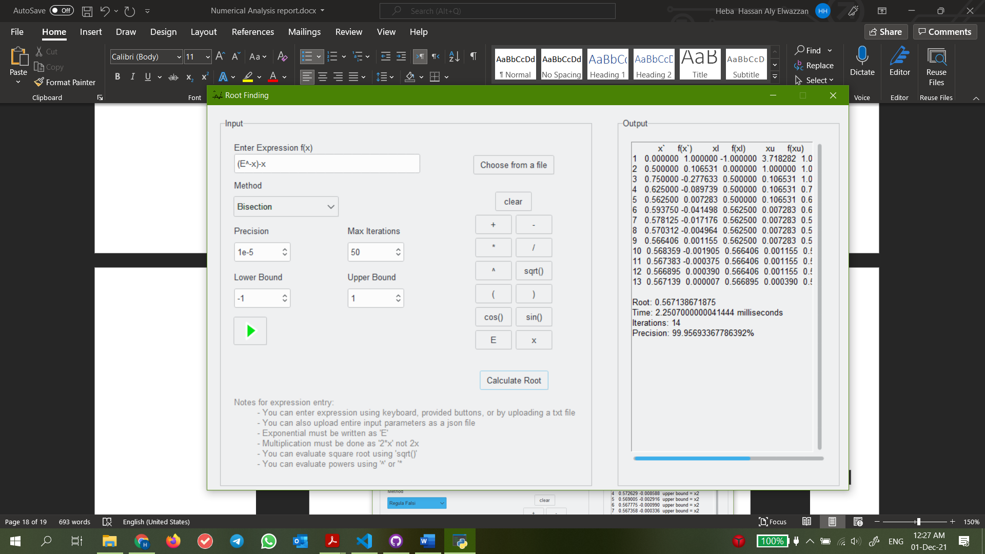 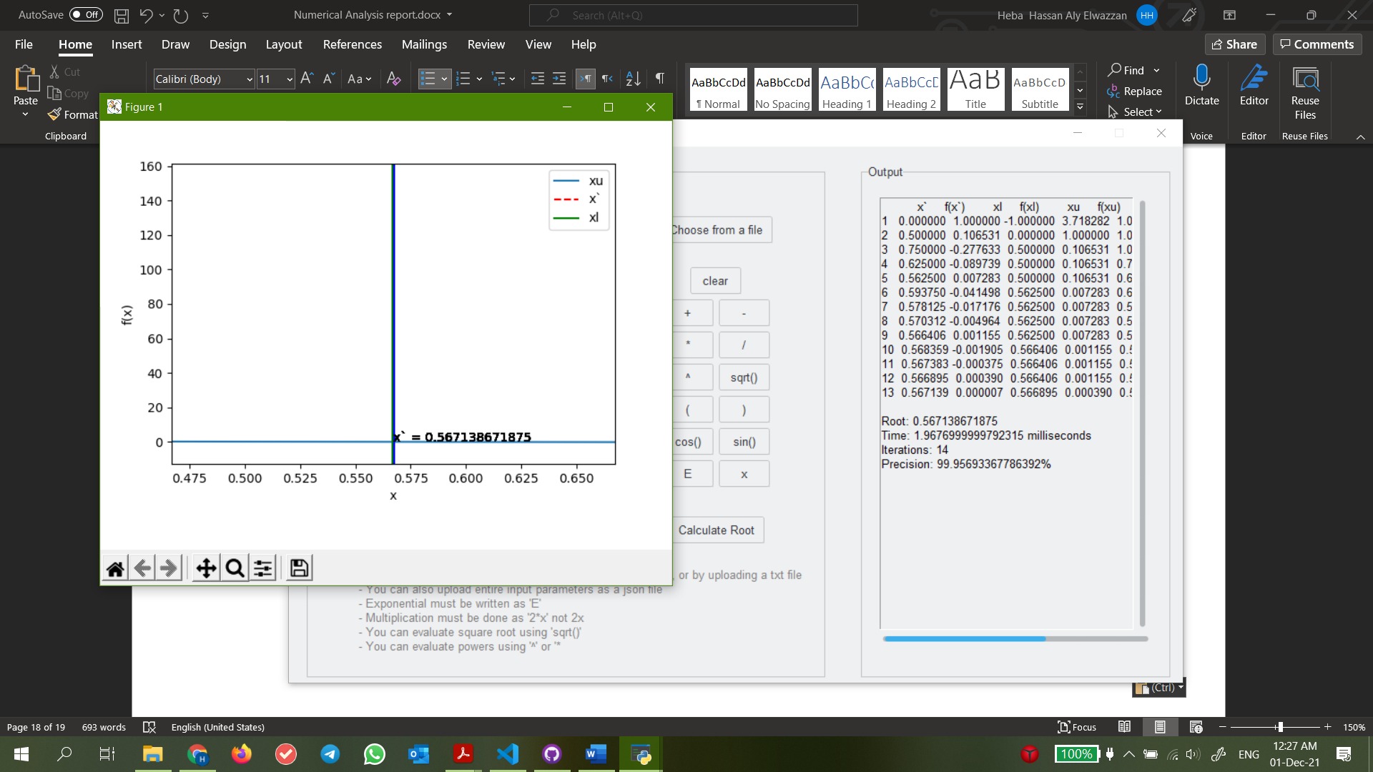
* Regula Falsi method 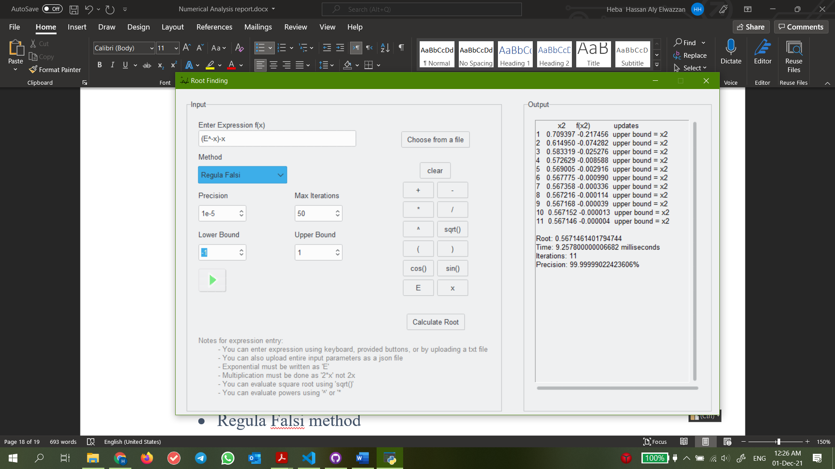
* Fixed Point method 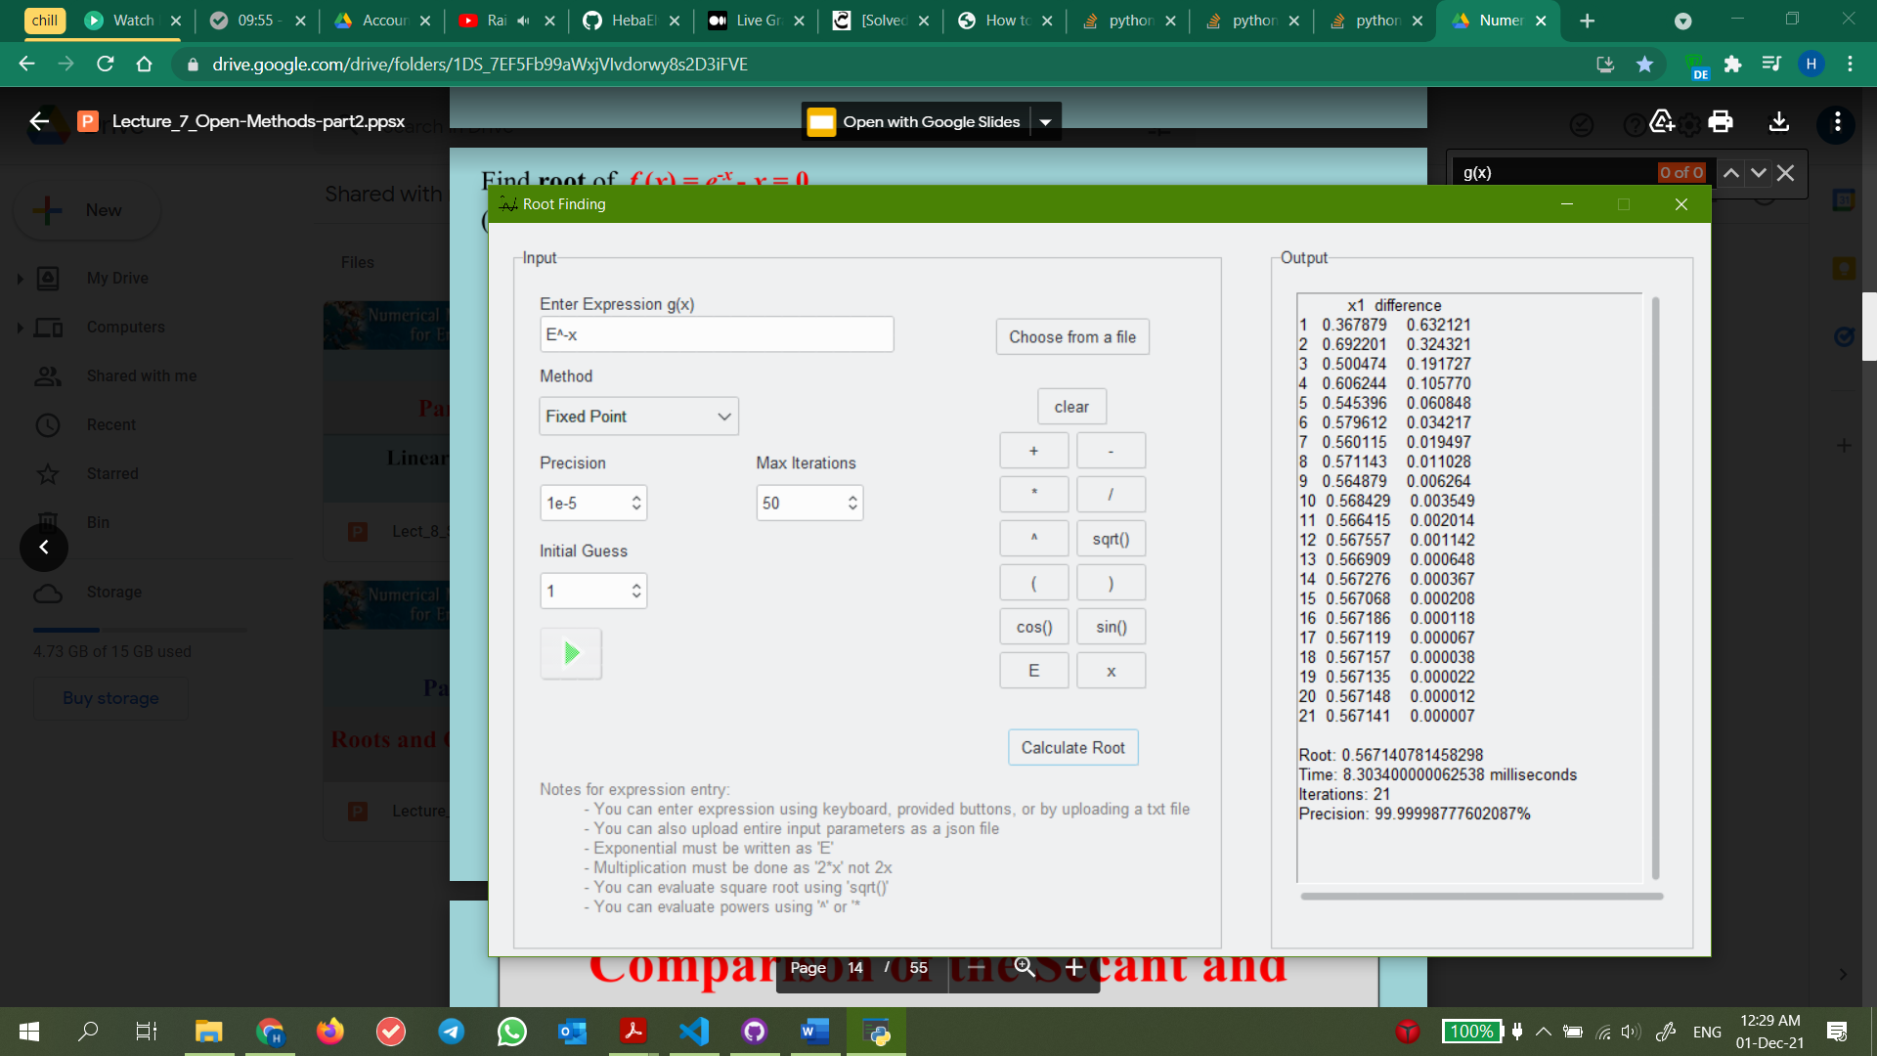
* Newton Raphson method 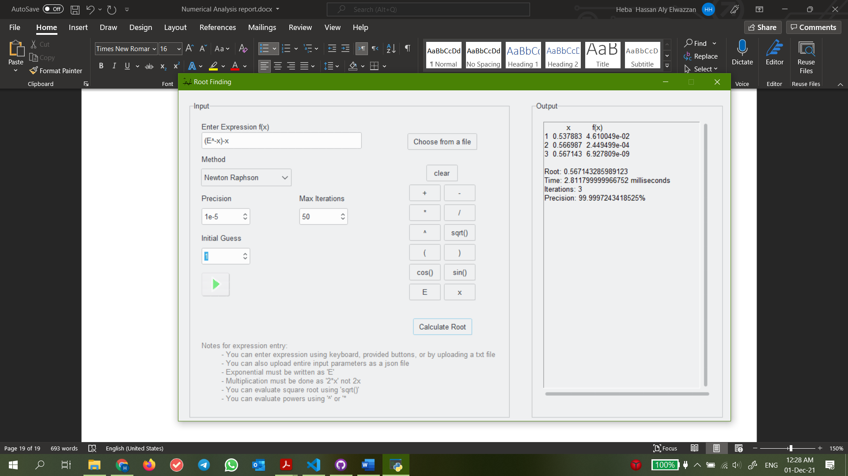
* Secant method 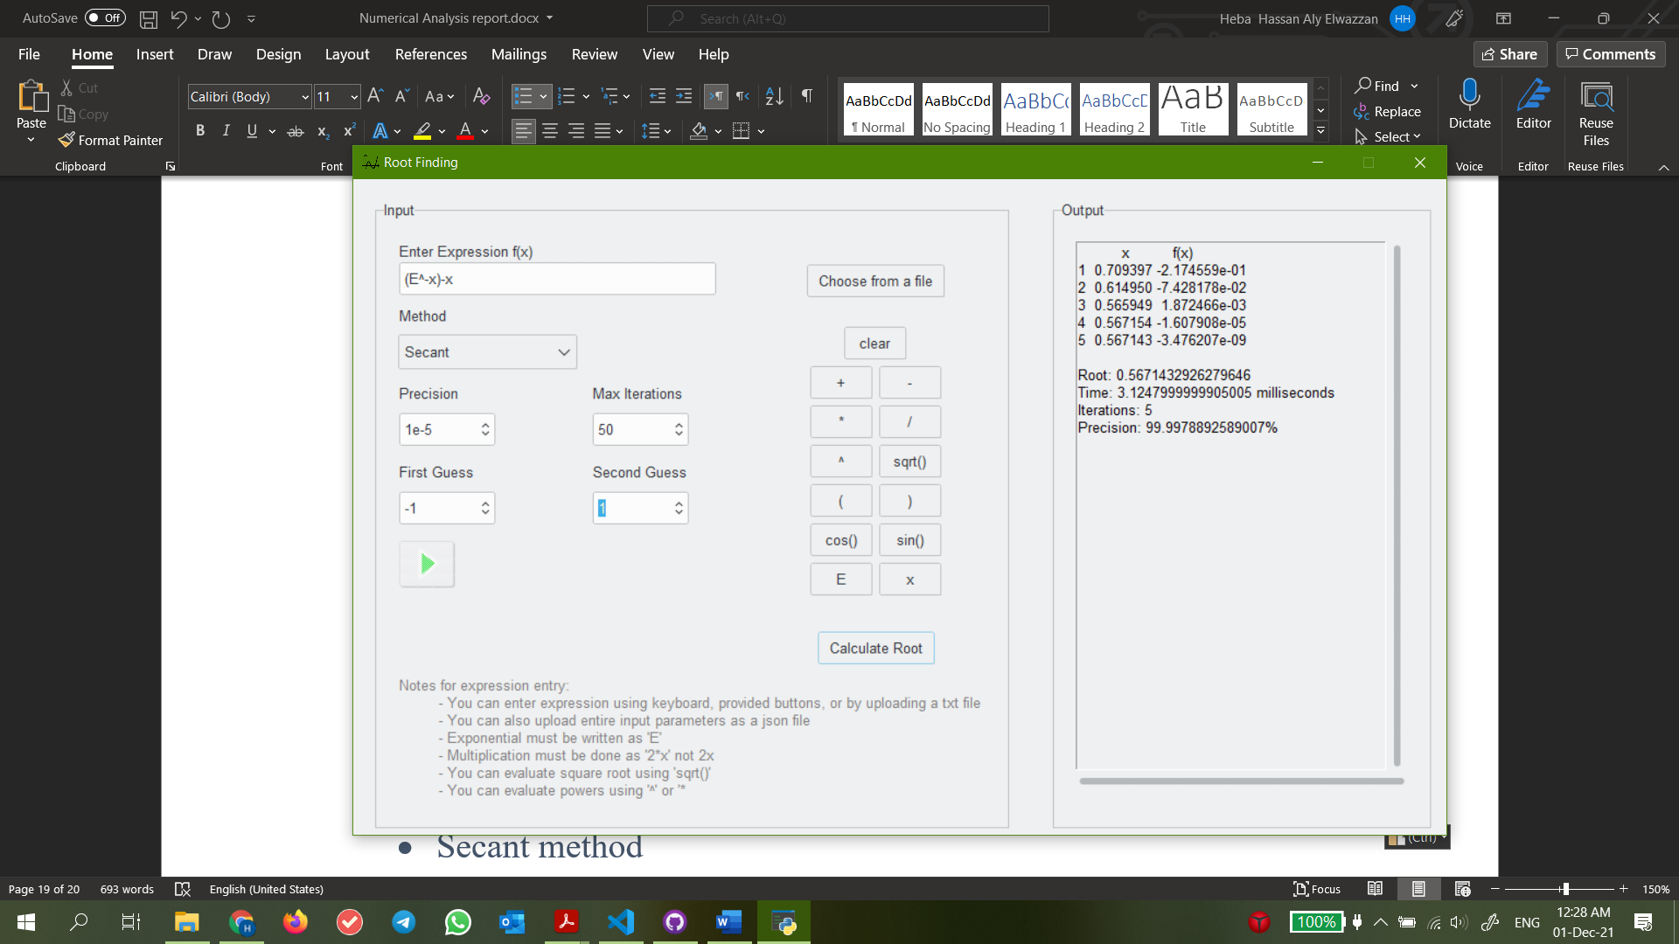

Observations

Newton Raphson was the most efficient while fixed point was the least.

Secant’s performance would have been better had we been able to set one of our guesses to 0. However, due to program limitations, this would have caused a division by zero error.

**Problematic functions:**

Test case 1: x^2+1(imaginary roots)

Bisection Method:

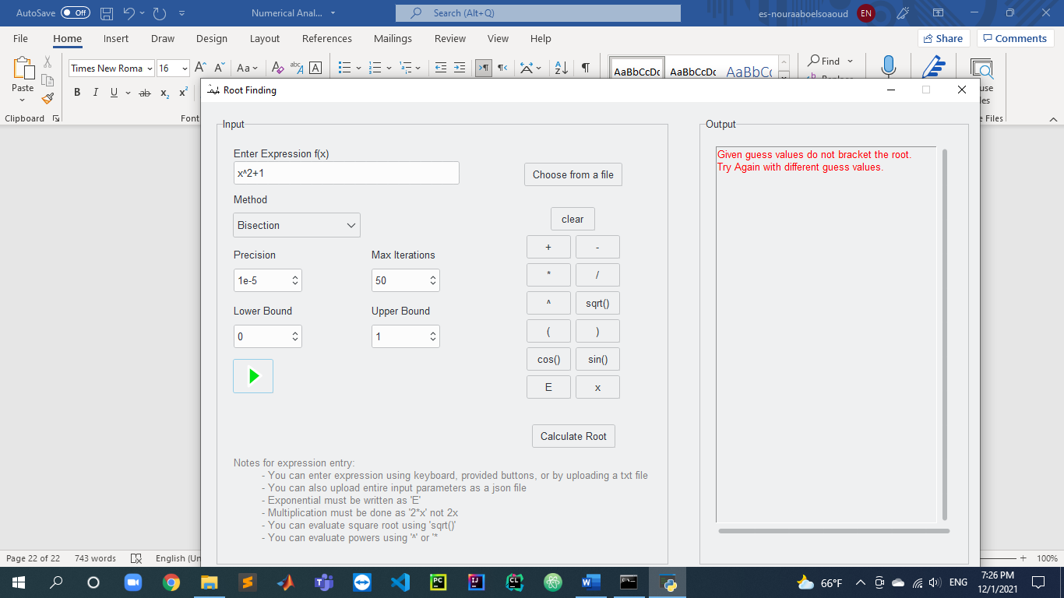

Regula Falsi:

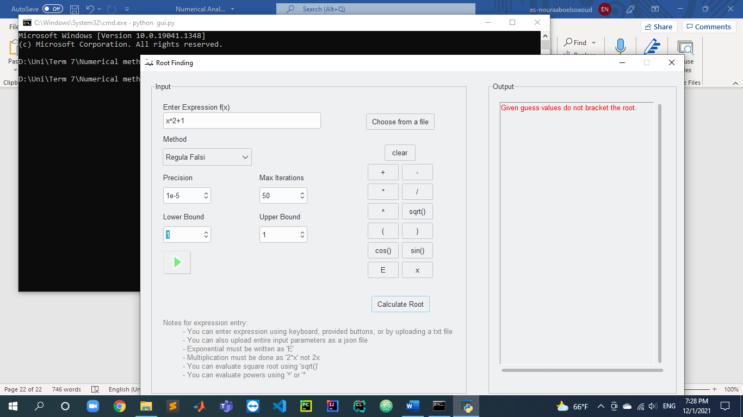

Test case 2:

x^2+2x-3(not convergent)

Fixed point:

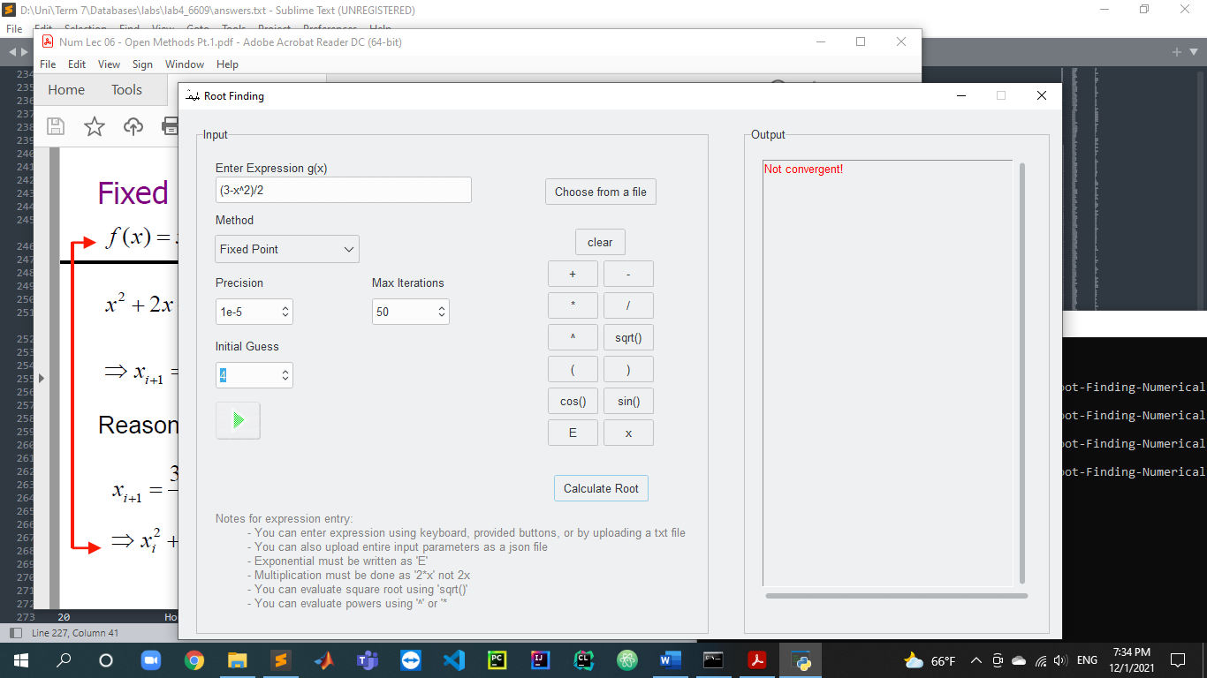

Test case 3:

x^3+2 (inflection point) division by zero

Newton Raphson:

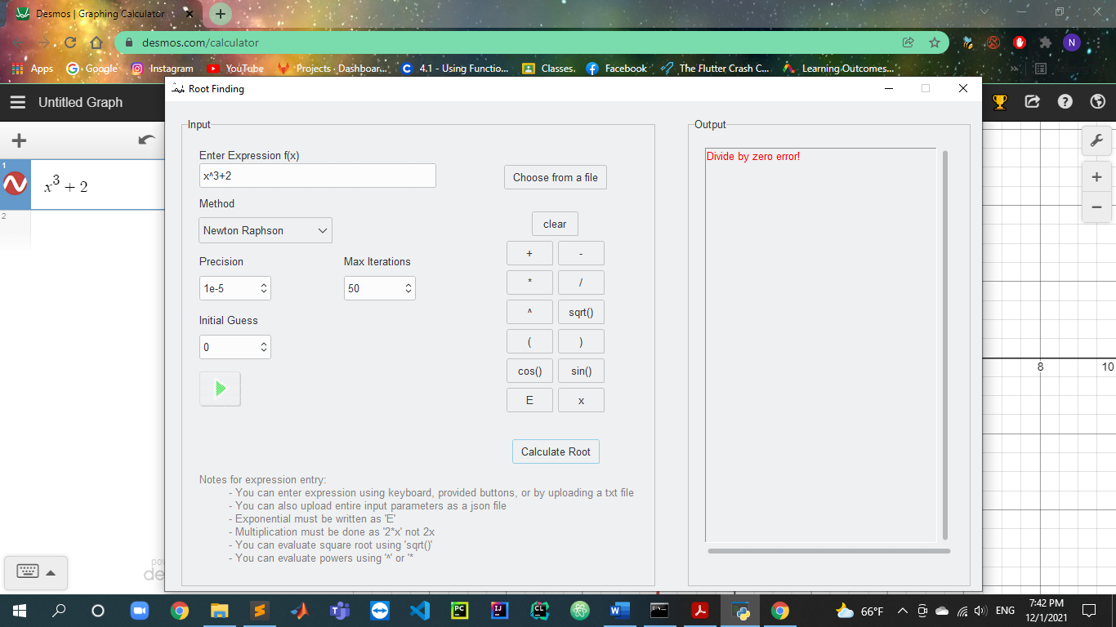

Secant method:

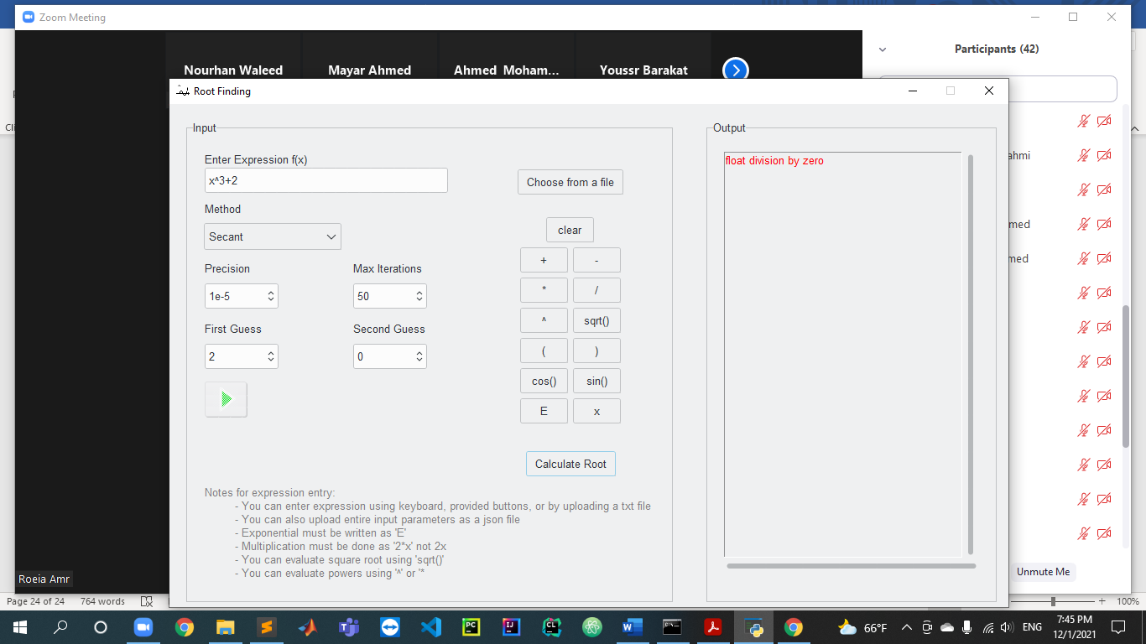

**Note:**

The theoretical bound error is included and is calculated correctly, it just doesn’t appear as the screen is too small, you can view it by expanding the window